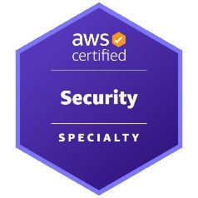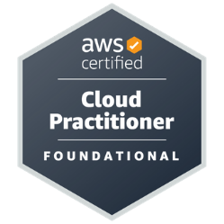

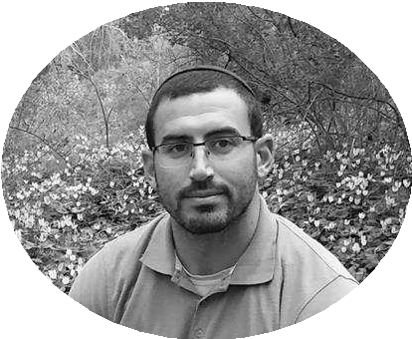

# PROFILE

# DevOps Engineer with extensive experience designing, deploying, and managing cloud infrastructure using Terraform, automating CI/CD processes, and configuring systems across Linux and Windows environments. Strong background in information security, system monitoring, and Python, Bash, and PowerShell scripting. A proactive and collaborative team player with broad system-level vision and fast learning abilities.

# Technologies & Skills Cloud & Infrastructure: AWS, Azure, GCP, Terraform

# Containers & Orchestration: Docker, Kubernetes, Helm

# CI/CD & Automation: GitHub Actions, Azure DevOps, ArgoCD, SSDLC

# Monitoring & Analytics: Prometheus, Grafana, Dynatrace, Splunk, SolarWinds

# Security & Protocols: WAF, SSL/TLS, PKI, QRadar, Qualys

# Systems & Scripting: Linux, Windows, Bash, Python, PowerShell

# Databases: MySQL, MSSQL

# ABOUT ME

diligent, dedicated, ambitious, organized, and a fast learner.

# CONTACT

PHONE: 0546-610754

WEBSITE:

[www.linkedin.com/in/imri-shorek](http://www.linkedin.com/in/imri-shorek)  
<https://github.com/Imrishorek1>

Email: [Imrishorek1@gmail.com](mailto:Imrishorek1@gmail.com)

IMRI SHOREK

## Interested in DevOps or DevSecOps roles EDUCATION Cyber and information security at HackerU

*August 2020 – December 2021*

I finished with a score of 93.2.

### B.A M.A at Arabic Language, Islam and Literature Bar-Ilan University

*2013 - 2016*

I finished with a score of 94.5.

## WORK EXPERIENCE

**Cloud Monitoring Specialist – Mizrahi Tefahot Bank (via Comblack)**

*Oct 2024 – Present*

* Designed and implemented observability solutions for AWS and Azure environments
* Authored procedures and deployed Splunk, Dynatrace, and SolarWinds
* Managed digital certificates, encryption protocols, and PKI infrastructure

**DevOps Engineer – Malam Team**

*Jul 2023 – Oct 2024*

* Built IaC-based infrastructure on AWS using Terraform
* Managed CI/CD pipelines, integrated Trivy and SonarQube for security scans
* Developed full automation scripts using Bash, Python, and PowerShell

**Support Engineer – Leumi Bank (via Malam Team)**

*Jul 2022 – Jun 2023*

* Provided technical support to 500+ global developers in DevOps, systems, and networking domains

**SecOps – GRSee Consulting**

*Jun 2021 – May 2022*

* Delivered security consulting services across AWS, Azure, and GCP
* Identified vulnerabilities, trained development teams, and managed mixed server environments

## Selected DevOps Projects

**Secure Netflix Deployment on Kubernetes:**

* Built Jenkins CI/CD pipeline with integrated Trivy & SonarQube scans, deployed to EKS
* Implemented Grafana/Prometheus monitoring stack and used Helm for secure deployments

**Secured VPN Connection to AWS RDS from On-Prem Server:**

* Used Terraform to create client_vpn_endpoint, manage certificates, and DNS configuration

**Full Observability Stack with Otel-Demo:**

* Enabled tracing, logging, and metrics collection across microservices using Jaeger, Grafana, and Prometheus